The vision of the AgrAbility Program is to assist farmers, ranchers, other agricultural workers, and farm family members impacted by disability. Each year, AgrAbility staff members in 25 states provide a variety of services to this clientele, including on-farm assessments, educational events, and information/referral services.
To support both AgrAbility staff members and their clients, the National AgrAbility Project holds the annual AgrAbility National Training Workshop (NTW), the premier event addressing issues of disability in agriculture. The NTW provides education and training through plenary sessions, breakout sessions, and tours.
The next NTW is scheduled for March 31-April 3, 2014 and will be held in Lexington, Kentucky. In previous years, our conference has been attended by up to 225 people representing 38 states, more than 30 of whom were farmers on scholarship. Additionally, we have had representatives from Canada, Sweden, and Brazil in attendance. These numbers represent records for the conference that we expect to continue to rise. In order to make this workshop a success, we are asking for your support to help sponsor any portion of the NTW to enable us to make this event the best one yet.
It is the goal of the National AgrAbility Project to keep the registration fee and other expenses as low as possible to allow as many AgrAbility staff members, clients, and rural health and agriculture professionals to attend as possible. To achieve this goal, we need your help. Please see the enclosed sponsorship form for information on sponsorship levels.
Your time and consideration is greatly appreciated. If you have any questions or would like to discuss the options available in more depth, please contact Kylie Hendress at 765-494-6679 or khendres@purdue.edu.

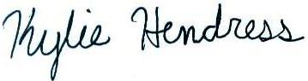
Kylie Hendress
Engagement Coordinator
National AgrAbility Project
www.agrability.org
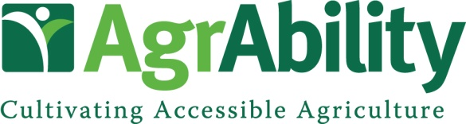

National Training Workshop
Lexington, KY March 31-April 3, 2014

Sponsorship Contact Information

Company Name:
Contact:
Address:
City:
State/Province: Zip Code:
Phone: Fax:
Email: Website:
Would you like to reserve a booth space?  Yes   No Do you need electricity?   Yes   No
Benefits to Sponsor

- Complementary booth space at the NTW trade show/expo (for sponsorships of $800 and above)
- Complementary registration for one company representative (for sponsorships of $800 and above)
- Signage and verbal recognition throughout the National Training Workshop
- Company name and logo on NTW schedules and programs
- Company logo displayed on the AgrAbility NTW website with a link to the company’s website
- Company listed as a sponsor on promotional materials which will be distributed nationwide

Suggested Sponsorship Opportunities

Bronze Level: Under $1000
Hospitality Room: $800
Promotional Giveaways: $1,000
Speaker Gifts: $1,000

Silver Level: $1001-$3000
Pre-Conference Tour: $1,500
Morning Break: $1,500
Afternoon Break: $2,500
Gold Level: $3001-$5000
Conference Tour: $3,100
Breakfast: $3,500
Welcome Reception: $4,000

Platinum Level: Over $5000
Keynote Speaker: $5,000
Lunch: $5,500
Banquet/Benefit Auction: $10,000

We would be glad to discuss other options to customize your sponsorship. Please call or email.
All donations are tax deductible and are administered by the National AgrAbility Project at Purdue University. Checks should be made payable to Purdue University. Mail to Breaking New Ground Resource Center, Purdue University, 225 South University St, West Lafayette, IN 47907.

